Do zoos help or harm animals?

What do you think? Do you agree or disagree? Perhaps you can
think of ideas for both sides of this topic.

Write to convince a reader of your opinions:

- Start with an introduction.
- Write your opinions on this topic.
- Give reasons for your opinions. Explain your reasons for your opinions.
- Finish with a conclusion. Sum up your writing to convince a
reader of your opinions.

Remember to:
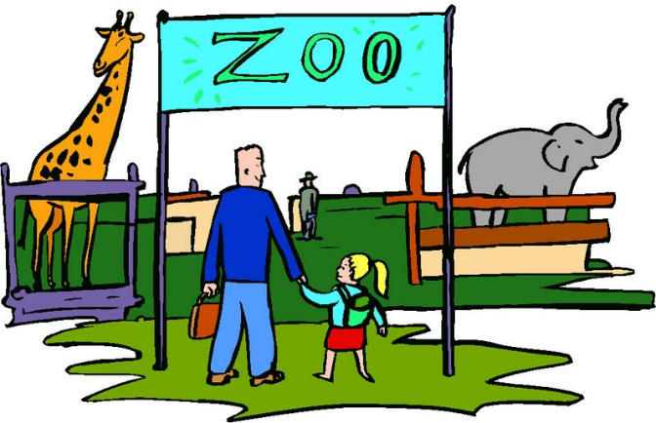
- Plan your argument
- Choose your words carefully to convince a reader
- Write in full sentences
- Pay attention to spelling and punctuation
- Use paragraphs to organise your ideas
- Check and edit your writing

